The European Business Organization World Wide Network (EBO WWN) is delighted to invite you for a special regionally-focused webinar, dedicated to the impact of COVID-19 on the regional economies and business environment.
Details:
Date: 02 July, 2020
Time: 12:00 PM (CET), Brussels time
Organizers: EBOWWN

Program
12:00 Welcome remarks – Mr. Jason Collins, President of EBO WWN
DG GROW International Relations Officer Mr. Vladimir Zuberec
12:10 Presentations
12:10 EBO Armenia - Ms. Diana Sarumova, Executive Director
12:20 EBO Belarus- Mr. Igor Severin, Consultant to EU Delegation
12:30 EBO Georgia - Mr. David Lawrence Lee, Chief Executive Officer
12:40 EBO Kazakhstan - Ms. Julie Kussidi, Executive Director
12:50 EBO Moldova - Ms. Mariana Rufa, Executive Director
13:00 EBO Northern Macedonia - Mr. Dimitar Ristovski, Executive Director
13:10 EBO Russia - Mr. Tadzio Schilling Chief, Executive Officer
13:20 EBO Ukraine – Ms. Anna Derevyanko, Executive Director
13:30 Moderated Panel discussion
14.00 Closing
This event is for members only. Kindly note that there are limited seats available. The organizers reserve the right to change the program content without giving prior notification or any reasons thereof.

Moderator
Mr. Jason Collins
Chief Executive Officer, EBO Australia
Chairman, European Business Organization Worldwide Network (EBO WWN)

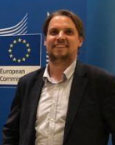
Mr. Vladimir Zuberec
DG GROW International Relations Officer Mr. Vladimir Zuberec

Speakers
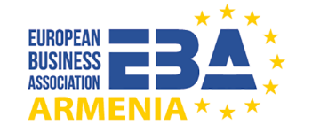
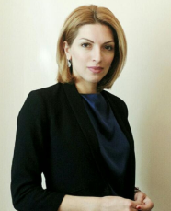
EBO ARMENIA
Ms. Diana Sarumova
Executive Director
Vice-President of EBO WWN
The European Business Association (EBA) Union of Legal Entities was founded in October 2015 under the support of EU Delegation to the Republic of Armenia.
The main objective of EBA is supporting EU and local business representatives operating in Armenia and facilitate the integration and cooperation between Armenia and the European Union as well as to improve business environment and investment climate.
The EBA is functioning as a voice of EU businesses in Armenia to direct their needs toward Armenian authorities and advocating their interests for the elimination of corresponding obstacles. The EBA is promoting fair, open and productive relationship between business and the government implementing and developing PPD (Public Private Dialog) Platforms in Armenia. As a result, it provides enhancement of competitiveness of the private sector through company capacity strengthening, increasing the transparency of governance and the business environment. At the same time the EBA is increasing the level of integration and cooperation of Armenian and European companies through conducting appropriate activities for enlarging business connections, distributing information on corresponding requirements.

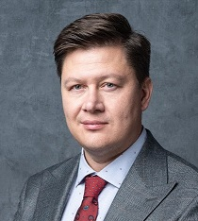
EBO BELARUS
Mr. Igor Severine
Consultant to EU Delegation
The European Business Association in Belarus is currently being registered with the support of the EU Delegation. The Association will include between 30-50 international companies and will help to consolidate and institutionalise the European business interests in Belarus by promoting the EU-Belarus economic, trade and investment cooperation through the establishment of a permanent business support organisation. In addition, the development of such institution means reducing barriers to doing business and promoting an inclusive entrepreneurial culture that provides opportunities for all citizens to gain a well-paid job or develop cross-border business cooperation.
The association will work to empower the private sector to actively participate in the democratic process through partnerships with local business associations, chambers of commerce, and think tanks. Using advocacy tools such as coalition building, grassroots outreach and public-private dialogue it will provides opportunities to a wide range of European private companies in their efforts to support strong, inclusive economic growth and bolster democracy though the free market development in Belarus.

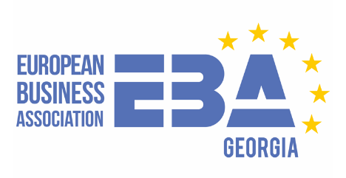
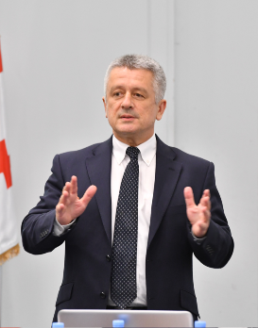
EBO GEORGIA
Mr. David Lawrence Lee
Chief Executive Officer
The concept for the European Business Association in Georgia was devised by the founders in 2012 and presented to the European Delegation and other European embassies. At that time, it was decided that Georgia was not ready for a pure play European Business Association.
Following the signing of the Association Agreement in 2014 and the granting of the Visa-free regime in 2017, the initiative was again activated with help from the European Business Associations in Moldova and Armenia and in close consultation with diplomats and advisors from the European Union in Brussels and Georgia.
The European Business Association in Georgia is differentiated from other associations in its European membership structure, online format and special focus on SME and regional development. Operating across the whole of Georgia, the Association is prohibited from supporting political parties and companies that do not meet the Association’s strict Code of Conduct.
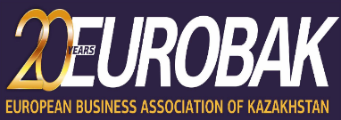
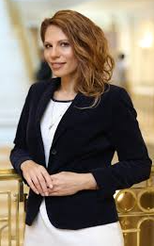
EBO KAZAKHSTAN
Ms. Julie Kussidi
Executive Director
European Business Association of Kazakhstan (EUROBAK) is a non-commercial organization representing the European business community in Kazakhstan. It was formed upon the joint initiative of EU companies, working and investing in Kazakhstan, and the Delegation of the European Union to Kazakhstan.
It plays a key role in promoting and nurturing mutual understanding between Kazakhstan and the countries of the European Union in both business and social spheres. At present, EUROBAK membership includes the leading European companies and institutions doing business in Kazakhstan, as well as large diplomatic community.

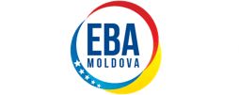
EBO MOLDOVA
Ms. Mariana Rufa
Executive Director
European Business Association Moldova is an independent, non-government organization, aimed at aligning the national economy and business legislation to the EU standards, and promote European values and best business management practices in the Moldovan entrepreneurial community. EBA Moldova is Member of EBO Worldwide Network.
EBA Moldova was designed to serve its beneficiaries in the three main interconnected areas:
- By enhancing the Business Environment of Moldova through LOBBY activities
- By streamlining Business promotion Moldova-EU through a certain range of SERVICES
- By offering Business Support to its members and the stakeholders, acting as a RESOURCE CENTRE
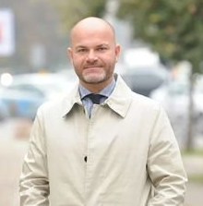
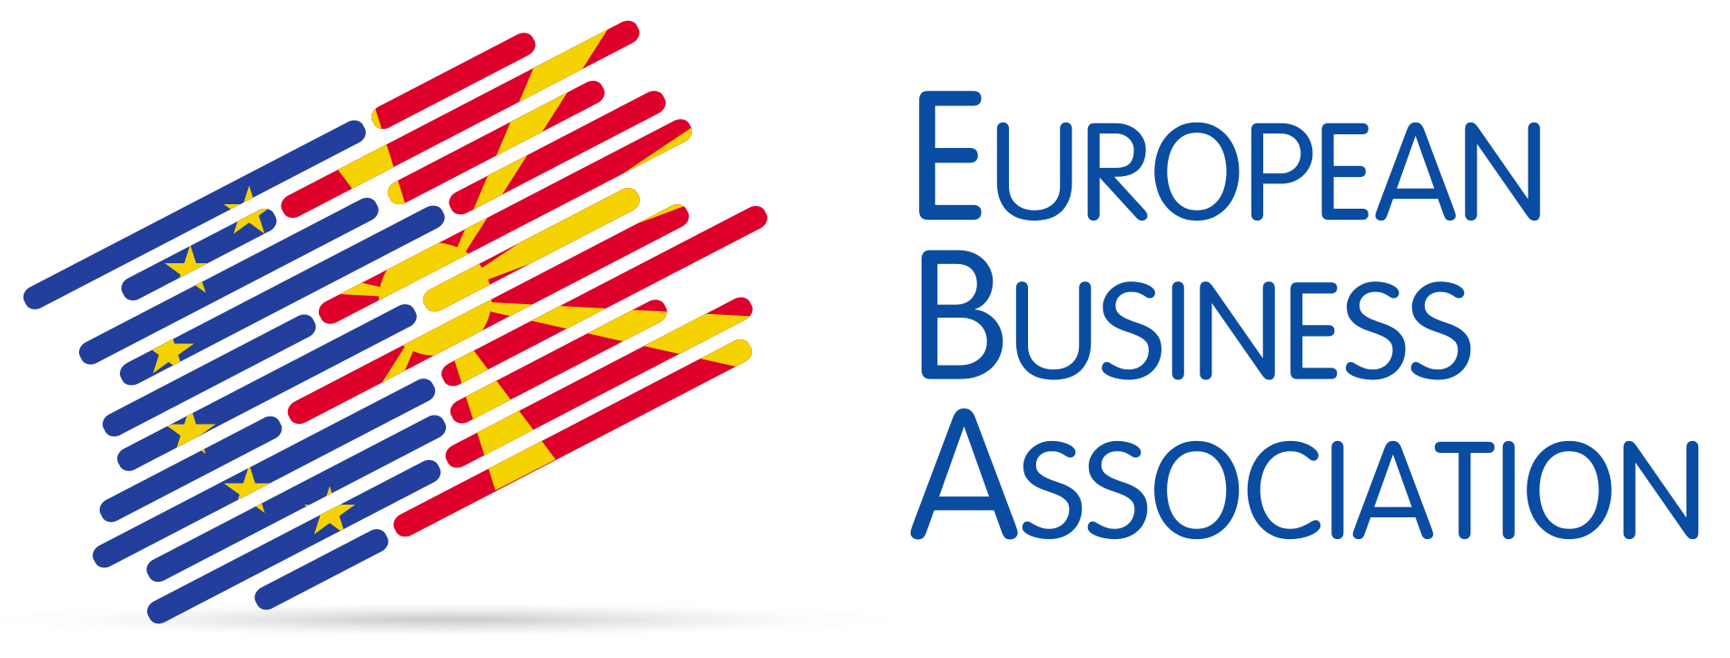
EBO NORTHERN MACEDONIA

Mr. Dimitar Ristovski
Executive Director
The establishment of the European Business Association was a project financed by the European Union and conducted by the European Agency for Reconstruction, that was initiated in February 2004. The project ended in September 2004 with successful incorporation of the European Business Association as self-sustainable, non-governmental and non-political organization.

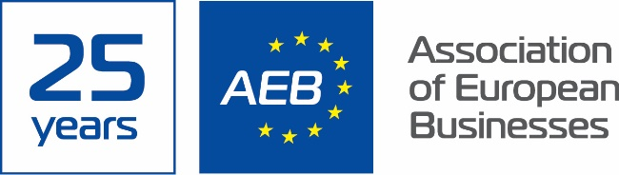

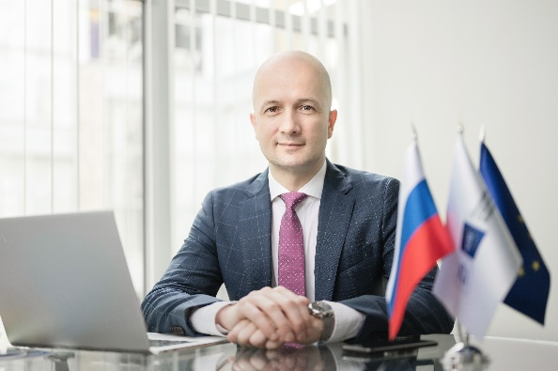
EBO RUSSIA

Mr. Tadzio Schilling
Chief Executive Officer
The Association of European Businesses is the main representative body of foreign investors in Russia. Founded in 1995, the AEB is an independent non-profit organization of over 500 European and Russian companies. The AEB members are multinational corporations and small and medium-sized enterprises. They all share a commitment to boosting cooperation between the EU and Russia, as well as the desire to improve the investment climate of the Russian Federation.
The AEB includes 60 committees, subcommittees and working groups that are engaged in lobbying on a wide range of issues in various business areas including energy, transport and customs, agriculture, air travel, passenger cars and commercial vehicles production, legislation, taxation, banking, real estate, crop protection products and many others. These committees work closely with the European and Russian authorities, and provide comments and suggested changes to the draft laws of the Russian Federation.

EBO UKRAINE
Ms. Anna Derevyanko
Executive Director
EBA Ukraine is inspired by EU values. It works to make Ukraine a better place for business.
Established in 1999, the EBA provides a forum in which members can discuss and find solutions to common problems affecting business in Ukraine. This initiative was initially supported by the European Commission and has grown to become one of the largest and most influential business communities in the country.
With more than nine hundred members, the European Business Association (EBA) is the largest premier union of businesses operating in the Ukrainian market.

